**A contrast camera trap imagery in Mojave National Preserve and Carrizo National Monument to examine animal interactions with foundation plant species**

**Nargol Ghazian**

**Honours Thesis**

**Faculty of Science**

**York University**

**Fall-Winter 2017-2018**

**Supervisor: Dr. Christopher Lortie**

**Advisor: Dr. Suzanne MacDonald**

**Abstract**

Understanding the positive role of foundational species in desert ecosystems has become increasing important. Foundational species are able to directly or indirectly facilitate other taxa through various mechanistic pathways. However, much of recent research has been primarily focused on plant-plant positive interactions. In this study we investigated the ability of foundational plant species *E. californica, L. tridentata*, and *C. acanthocarpa* to act as benefactors. We hypothesized that these species are in fact able to positively impact other taxa such as vertebrates. The above was done through camera trap imagery data collected during the spring of 2017 in the Mojave National Preserve and the Carrizo National Monument. There were statistically significant differences for shrub volume and the capture instances per microsite. This showed that canopy volume does play a role in attracting animals by participating in shelter and refuge effects. Although, Buckhorn was shown to be the best ‘magnet’ amongst the three plants, there was no significant difference between the open sites and Buckhorn, suggesting that animal-plant interactions may be species-specific, site-specific, and dependent on the circumstance. Larrea showed the highest level of animal richness due to its environmental amelioration pathways and its vital role in the community assemblage. Seasonal, behavioural and atmospheric difference not explored in this study may also be aspects that influence the above interactions. These findings are important not only because they fill knowledge gaps in this area of research, but also because they could be used for restoration purposes following extensive disturbance in desert ecosystems.

**Keywords:** Foundational species, camera traps, positive interactions, facilitation, shrubs, deserts

**Introduction**

Animal observation is an important form of behavioural and ecological research in many ecosystems. Camera traps provide a mechanism to collect observation data on animals in their natural habitat and interactions with their environment with relatively limited human disturbance (O’Connell et al. 2011). Besides their use in wildlife viewing and hunting, camera traps have been used in studies that focus on nest ecology, detection of rare species, estimation of population size and species richness, behavioural studies, habitat use, and occupation of human-built structures (Cutler and Swann 1999; O’Connell et al. 2011 ). The current technology in most camera traps is able to detect changes in animal movement through heat-in-motion (Francesco Rovero et al. 2013) via a passive-infrared sensor. Hence, camera trap allow for a versatile method that can be employed in various fields of research.

One of the major uses of the device, particularly in ecology, has been to record vertebrate activity patterns used to determine parameters such as occupancy, abundance and diversity (Karanth et al. 2004; Kelly et al. 2008). Perhaps the greatest advantage of this sampling method as opposed to other efforts is that it can record accurate data without the animal being captured or the researcher being present. The earliest case study concerning abundance was first done by Karanth (1995) for the *Panthera tigris* population using capture-recapture models. Though, later studies concerning abundance and density have focused on jaguars *Panthera onca* (Silver et al. 2004)*.* Additionally, diversity can also be determined through species richness and composition data from camera trap images (Rovero et al. 2014). Once used to determine abundance and diversity, the obtained data can be of great importance to conservational biologist for population management-purposes. It is important to note that well-designed studies involving camera traps also include measurements of covariates of the site: factor(s) beside the variable of interest that can affect the results such as temperature, sunlight intensity, and season. In addition, covariates are chosen based on how they influence the parameter of interest and the detection probability they provide (White 2005).

The Mojave National Preserve (35.0110° N, 115.4734° W), roughly 150 000 km2, is located in an area incorporating Nevada, California, Utah, and Arizona (Shryock et al. 2017). The climate is generally arid or semi-arid, through the north-to-south-oriented mountain ranges increase climate variability. Furthermore, annual precipitation ranges between 30-300 mm (Hereford et al. 2006). The maximum temperature can surpass 50°C whilst the temperature can fall below 0°C in the winter season. *Larrea tridentata* (Figure 2) is a dominant or co-dominant flowering shrub that is often found in sandy soils, desert pavements and well-developed cryptogram layer of the Mojave (Sawyer et al. 2009). The shrub is a long-lived evergreen extremely resistant to high temperatures. Larrea is well-studied with regards to pollination (Minckley et al. 2000), yet relatively under-studied in terms of association with vertebrate communities. *Cylindropuntia acanthocarpa,* (Figure 3)commonly known as Buckhorn cholla, is a shrub native to California belonging to the family *Cactacae* (Grant and Hurd 1979) and is somewhat under-studied.

Carrizo Plain National Monument (35.1914° N, 119.7929° W) is the largest remnant ecosystem of the San Joaquin Desert (Noble et al. 2016). Located in the south-eastern San Louis Obispo Country, precipitation in the monument ranges from 15 cm in southeast to 25 cm in the northwest. The shrub species of the region are important as they are beneficial to animals (Lortie et al. 2016). In addition, the dominant shrub species are *Ephedra californica* (Figure 4), commonly known as Mormon tea, and *Atriplex polycarpa*, known as saltbush (Stout et al. 2014). The species *E. californica* is a slow-growing shrub which spreads colonially in hot deserts. It is well-adapted to alluvial substrate and shifting sand, generally growing in elevations of 200-1200 m. Although severe fires can kill the plant (Anderson 2004), it is fairly resistant to moderate fires with the ability to sprout.

Vegetation commonly occurs in mosaic of patches which affects the distribution of the herbivores that prefers the particular type of vegetation (Cromsigt and Olff 2006). A study conducted by Bukombe et al. (2018) examining the distribution of ungulates across woodland, grassland and bush grassland found that habitat selection in dry and wet season differed between species and each species changed its selection between seasons in varying ways. This change in vegetation selection in dry and wet seasons could not be explained by predator limitation; a hypothesis which states that if predators limit herbivore abundance, then resources are not the limiting factor, competition will be weak and there habitat selection will not be significantly different between seasons. Shifts in seasonal selection could be due be explained by fluctuations in forge abundance (Sinclair and Arcese 1995), forge quality in relation to species functional differences (Hopcraft et al. 2012), and predation.

Alongside the landscape’s topography and the types of road present, a study by done by Dickson et al. (2005) investigating cougar movement in southern California concluded that the vegetative characteristic of the habitat does in fact influence the amount of time the animal spends in that area and how fast it moves through. Similar conclusions were made in a study tracking the displacement of Eleodes beetles in shortgrass prairie where net displacement was highly influenced by vegetation structure (Crist et al. 1992). Furthermore, displacement was found to be the highest in bare or grass areas, whilst being the lowest at cactus and shrub regions. Though mechanisms for these species-habitat associations were unclear, long-term, programmed biological responses (i.e. thermoregulation) to vegetation structural characteristics (Parmenter et al. 1989) in addition to refuge from predation (Parmenter and Macmahon 1988) could be underlying factors. Although beetles were found to be feeding in the in the vegetative cover types, the feeding frequency was not associated with any of the types. Additionally, the presence of vegetation can predict distribution, abundance and life history traits of herbivores and non-herbivores (Pettorelli et al. 2011). The distribution of herbivores specially depends on the suitability of the physical environment as well as the availability of main plant resources (Mysterud and Østbye1992). Moreover, covers, regardless of whether the cover type is vegetative or not, can impact microclimate, predation risk, food quantity and quality. Furthermore, foundational plant species defined by having a sole impact on the structure and function of an ecosystem (Angelini et al. 2011) can influence other taxa through positive interactions or facilitation (Bruno et al. 2003). These interactions can include but are not limited to shelter, refuge from predation, and seed trapping (Filazzola and Lortie 2014).

Vegetation, landscape, and local differences in seasonality are thus likely important to animals, and previous research has shown that camera traps have the capacity to detect these differences. We hypothesized that foundational plant species investigated in this study (*E. californica, L. tridentata*, and *C. acanthocarpa*) are able to positively act as benefactors for other taxa such as vertebrates through the numerous mechanistic pathways they provide. Camera trap images from two distinct desert ecosystems were used to study the above interactions.

**Materials & Methods**

**Camera deployment and imagery collected**

Camera traps (Browning brand) were set at the Mojave Desert and the Carrizo Plain National Monument. In the Mojave, the sites were divided into two categories corresponding to the shrub type: *L. tridentata* (Larrea) or *C. acanthocarpa* (Buckhorn). There was a total of eight microsites chosen at random for Buckhorn (Table 2). Cameras were set to survey on consecutive days from March 23rd, 2017 to May 3rd, 2017 (approximately a total of seven weeks); though, not all sites were recording during the full duration of sampling. Cameras at the Carrizo were also split into two categories, however in this case one category corresponded to the shrub *E. californica*, whilst the other was simply called ‘open’ and functioned as control to serve an estimate of important associational patterns with shrubs. Sampling took place for a total of three weeks and three days at 20 different microsites (ten for shrub and ten for open) (Table 3) from May 22nd, 2017 to June 15th, 2017. Unlike the Mojave microsites that remained at the same location for the duration of the sampling period, the Carrizo shrub microsites were altered each week. The open microsites did not have distinct coordinates as they were only few meters from those of the shrubs’. Furthermore, shrub dimension (length, width, and height) were recorded at all microsites in both the Mojave and the Carrizo for *E. californica*, Larrea, and Buckhorn (Table 4 and 5).

**Metadata**

A total of 102,398 and 209,714 images were collected in the Mojave and the Carrizo, respectively, which were saved as Join Photographic Expert Group (JPEG) format. These dataframes were then manually examined for the presence of animals. A datasheet was created where every row corresponded to a unique image. Additionally, data was recorded for the year, region, calendar date, microsite, rep, photo rep, and week number. If a vertebrate was present in the photo, further info on the type of vertebrate, time block, actual time, temperature, and additional observations were also recorded. Images from cameras were clear enough during both day and night (low light condition) to distinguish between animals. An animal was classified as present if as little as a section of a body part (i.e. tail) made it into the captured image. Vertebrates detected in the Carrizo included: jackrabbit (*Lepus californicus*), blunt-nosed leopard lizard (*Gambelia sila*), California kangroo rat (*Dipodomys californicus*), desert cottontail (*Sylvilagus audubonii*), San Joaquin antelope squirrels (*Ammospermophilus nelsoni*), and kit fox (*Vulpes macrotis*). With the exception of the lizard and the antelope squirrels, the rest of the vertebrates were also spotted in the Mojave, in addition to the Mohave ground squirrel (*Xerospermophilus mohavensis*) and the California thrasher (*Toxostoma redivivum*).

**Statistical Analyses**

All analyses were performed using R version 3.4.4 (R Development Core Team, 2017). Statistical workflows are available on:

https://cjlortie.github.io/Camtrap.contrast.2017/#camera_trap_contrasts.

Generalized linear models (GLM) were used to test for differences between foundational species with regards to variables such as capture rate, species richness, and size. GLMs allow for generalization of ordinary regression models when the distribution of the data does not fit a normal distribution (McCullagh 1984).

**Results**

Smoothed density plots of shrub size versus frequency of each foundational species showed an overlap of upper and lower quantiles (Figure 6). This means that there are significant differences in size between the three tested species (Gaussian, *p*>X2= 2.2e-16, *df=* 75). Capture rates were microsite-specific, varying from 0 to 0.4 images per second depending on the foundational species present (Figure 7, quasi-Poisson, *p*>X2= 0.0001021, *df=* 99). Specifically, the rate was statistically different between Buckhorn-Ephedra (Table 1, Tukey adjustment, *p=* 0.0038), Buckhorn-Larrea (*p=* 0.0409), and Ephedra-open (*p=* 0.0164). Hence, Buckhorn was shown to be the best ‘magnet’ for vertebrates, having a greater capture rate than both the Larrea and Ephedra. Despite this, the Carrizo ‘open’ sites outcompeted both species and were not significantly different from buckhorn (*p=* 0.8466>0.05). Animal richness was also significantly different between the four microsites (Figure 8, quasi-Poisson, *p*>X2= 6.385e-6, *df=* 102) where differences between Ephedra-Larrea (Tukey adjustment, *p*= 0.0024) and Larrea-open (*p*= <0.0001) were particularly important. Linear regression models demonstrated that shrub size is not significantly correlated with incidence of animal capture for any of the foundational species (Figure 10, Buckhorn, Ephedra, and Larrea adjusted r2= 0.2628, 0.01436, -0.0388, *p*= 0.07434, 0.2514, 0.43, and *df*= 8, 25, 7, respectively). Lastly, Buckhorn was found to be the best facilitator for other plants in the community (Figure 9, Gaussian (Rii), species *p*>X2= 4.616e-13, *df=* 457).

**Discussion**

Interactions between foundational species and other taxa is an increasing important area of focus as global desertification becomes a growing issue (Asner and Heidebrecht 2005). In particular, facilitation by shrubs has been an established mechanism, able to repair and maintain semiarid ecosystems (Lortie et al. 2017). Previous studies have explored the importance of foundational species on ecosystems (Angelini et al. 2011), their positive interaction with other similar taxa (Bruno et al. 2003), in addition to the mechanistic pathways through which they occur (Filazzola and Lortie 2014). Despite the variety of published literature on the topic, many have mainly focused on plant-plant interactions. In this study we wished to investigate the positive role of foundational plant species on other taxa such as vertebrates through imagery data collected from camera traps in two distinct desert ecosystems. We hypothesized that *E. californica, L. tridentata*, and *C. acanthorpa* can act as benefactors for vertebrates through the various mechanistic pathways previously discussed.

It was shown that there was a significant difference between the sizes of the three foundational species tested. Moreover, the animal capture rate was microsite-specific. Because size in this study was defined as volume, it can thus be said that canopy volume plays a vital part in the shrub’s role as a magnet for vertebrate taxa. This is consistent with assumption that the canopy volume is a primary mediator of structural facilitation for plants and animals, acting directly or indirectly in shelter and refuge effects (Badano et al. 2016; Bråthen and Lortie 2016). Buckhorn successfully outcompeted the other two species when it comes to capturing instances and was shown to be the best attractor for animals. A study done by Gómez-Aparicio et al. (2004) reported that small shrubs have significant positive effects for other plants. Buckhorn being the smallest of the shrub species demonstrated this by being the best facilitator amongst other plants in the community. Thus, the same theory could perhaps be applied to plant-animal interactions. Despite this finding, the open sites in the Carrizo were not significantly different from Buckhorn, suggesting that foundational species are used different at different sites. Hence, it could be said that foundational species not only have varying degrees of influence on other taxa, but also the directionality of this interaction may be site-specific. The idea that facilitation is species-specific has been previously explored by Callaway (1998), suggesting that positive interaction depend on species-specific traits and that beneficiaries are and are not randomly associated with benefactors depending on the circumstance.

Animal richness was significantly different between the four microsites and found to be the greatest for Larrea. Larrea’s ability to attract a diverse range of animals conceivably lies within its capacity to ameliorate harsh environmental conditions (Badano et al. 2016) by offering protection from high temperatures during day time (Drezner and Garrity 2003), providing higher availability of water and nutrients under canopy (Prieto et al. 2011; Quinos et al. 1998), and presenting shelter in low night temperatures (Cavieres et al. 2007). Furthermore, Larrea shrubs tested in this study were generally bigger than those of the other two foundational species, thus highly impacting the community assembly of different taxa (Maestre and Cortina 2005). Additionally, habitat selection can differ between species during dry and wet season, where each species can change its selection due to various causes (Bukombe et al. 2018). Though effects of seasonal changes on habitat selection were not explored in this study, it may be that Larrea showed the highest species richness because of the time of the year sampling took place.

Although capturing instances were the highest for buckhorn, capturing rate was not significantly correlated with any of the foundational species. This may be because camera trap capturing rate relies on sensed movement via any influence (i.e. wind) and not just movements particular to animals. Hence, daily atmospheric conditions could also be a factor influencing capturing rates.

Deserts are some of the harshest ecosystems that continue to exist in many parts of the world. Despite the severity of environmental conditions in these areas, positive interaction amongst various taxa continue to exist, regardless of how invisible they may seem to the naked eye. Foundational plant species are not only beneficial to other plants, but can also act as benefactors for vertebrate taxa, therefore impacting species richness and community dynamics through numerous mechanistic pathways. The above findings important as they fill existing novel gaps in the field of plant-animal facilitation research. In addition, the knowledge of these interactions can be especially valuable for conservational purposes in times of great disturbance. Future studies should focus on behavioural and seasonal changes that could influence the associational patters of foundational species and animals.

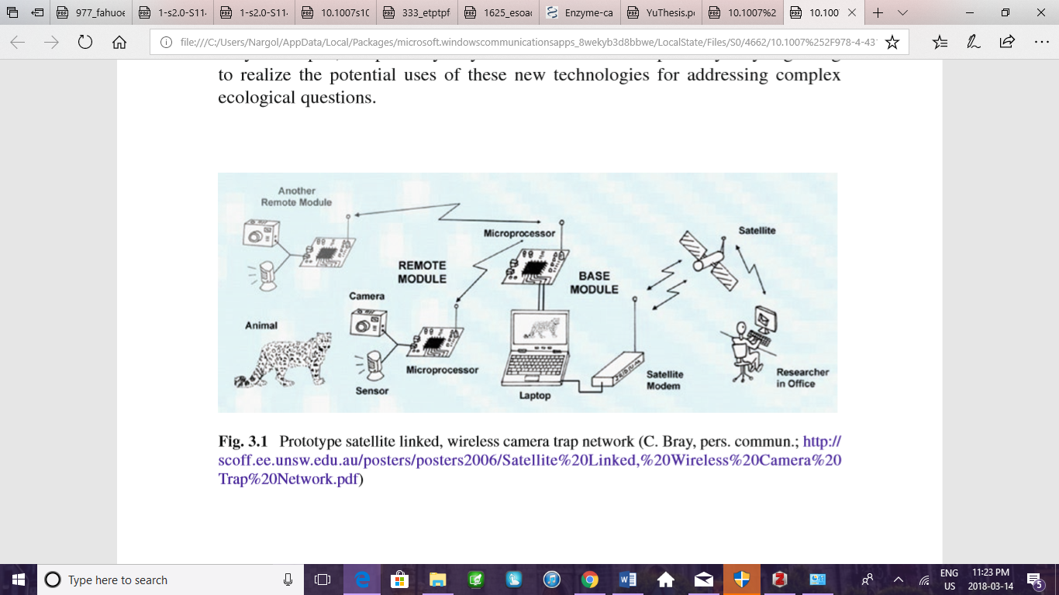**Figures**

**Figure 1.** Camera trap network with possible wireless, satellite linkage (O’Connell et al. 2011).

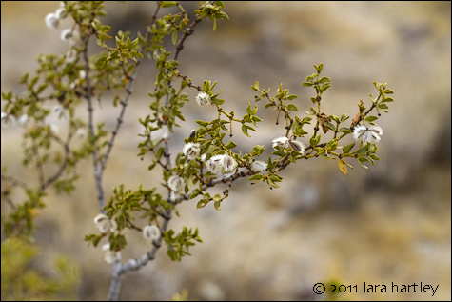

**Figure 2.** Close-up of *Larrea tridentata* shrub (Desert USA https://www.desertusa.com/flowers/Creosote-Bush.html [Date Accessed: March 20th. 2018]).

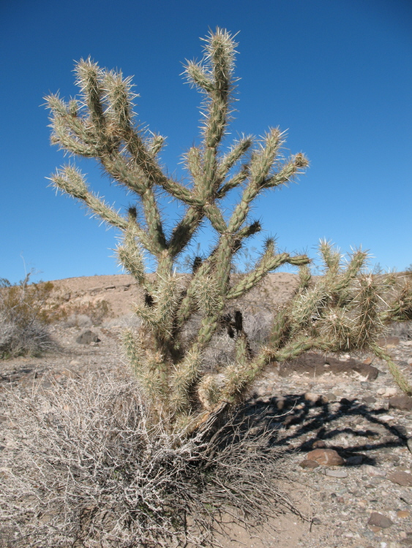

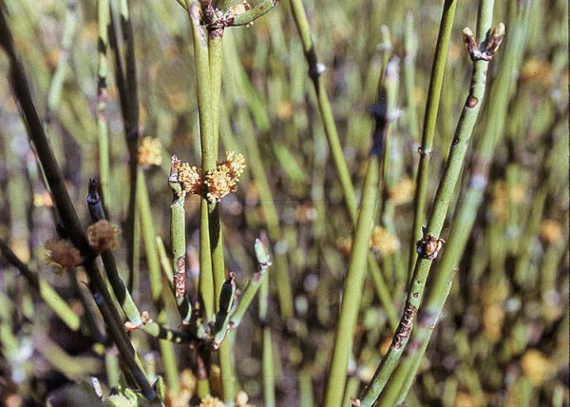**Figure 3.***Cylindropuntia acanthorpa* cacti (Calflora http://www.calflora.org/cgi-bin/species_query.cgi?where-taxon=Cylindropuntia+acanthocarpa [Date Accessed: March 20th. 2018]).

**Figure 4.** *Ephedra californica* buds (Guide Phytosanté http://www.guide-phytosante.org/minceur-nutrition/ephedra/ephedra-posologie.html [Date Accessed: March 20th. 2018]).

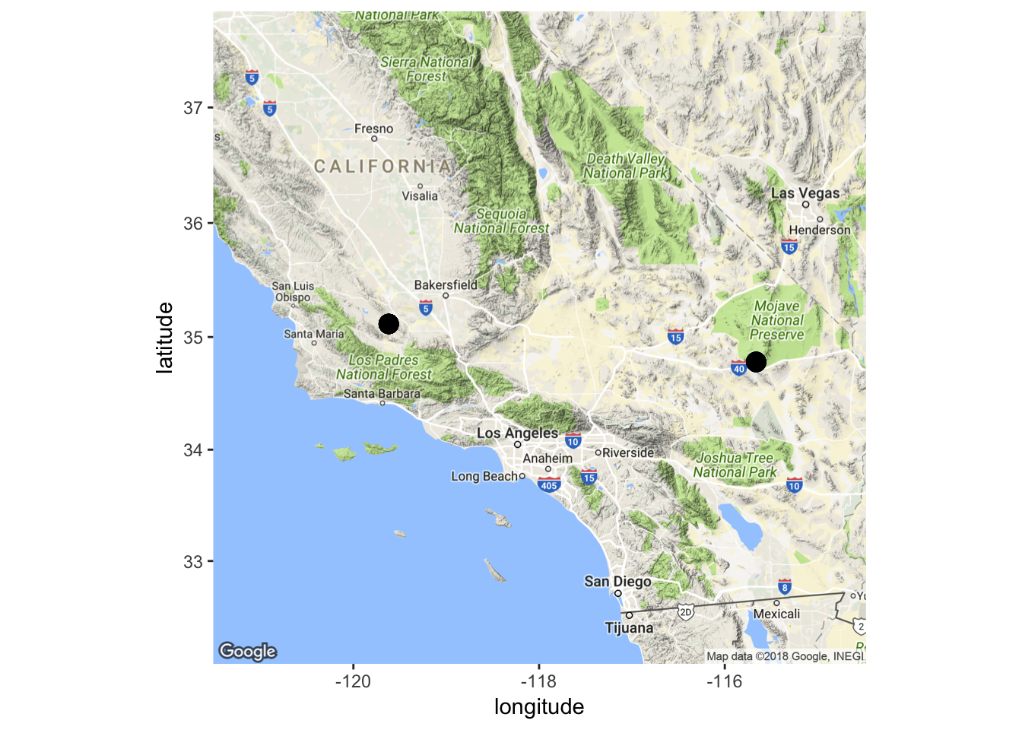

**Figure 5.** Location of the camera trapping research done at the Mojave National Preserve and the Carrizo National Monument in the growing season of 2017.

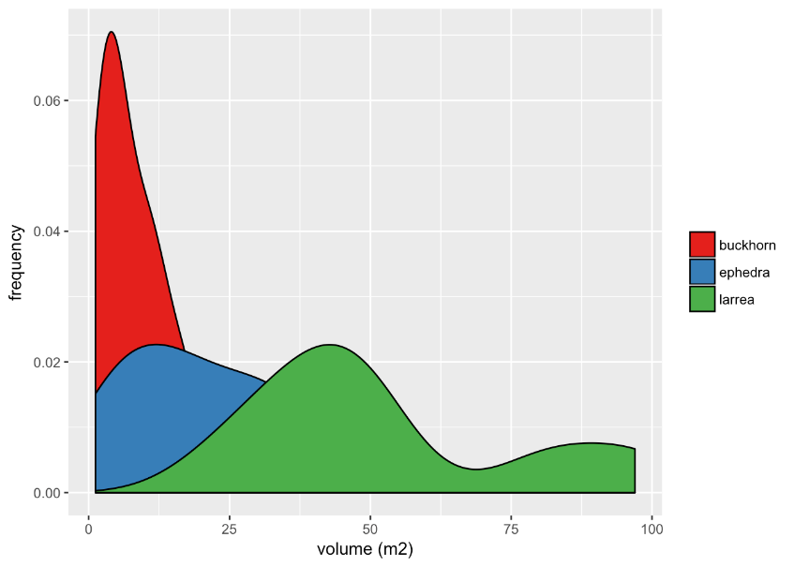

**Figure 6.** Smoothed density estimate plots for size of foundational species buckhorn, Larrea, and *E. californica.* Volume was calculated using height and width measures, where height is the highest vertical living stem of a given shrub. The frequency estimate demonstrates the probability of those measures occurring at a given volume on the x-axis.

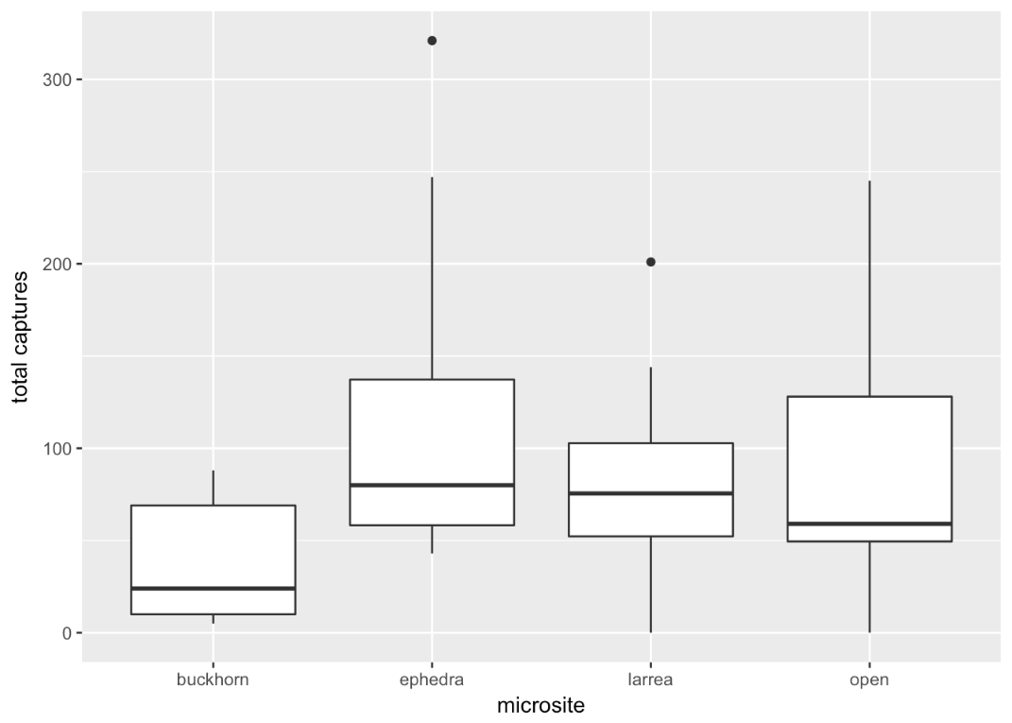

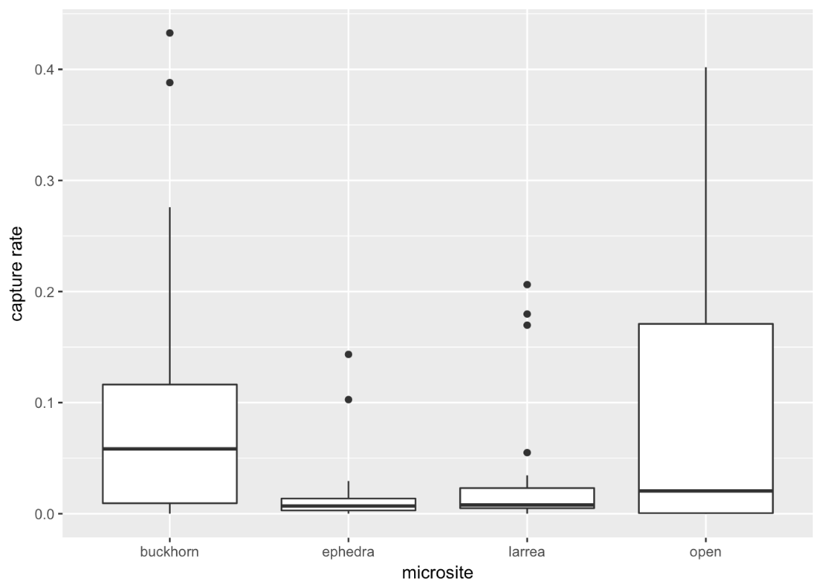

**Figure 7.** Boxplot showing the total captures and the capture rate at each of the four microsites: buckhorn, Ephedra, Larrea, and open. Solid middle lines shows the median of the data, whilst whiskers show 1.5 standard deviation. Solid dots are outliers >1.5 interquartile range (IQR).

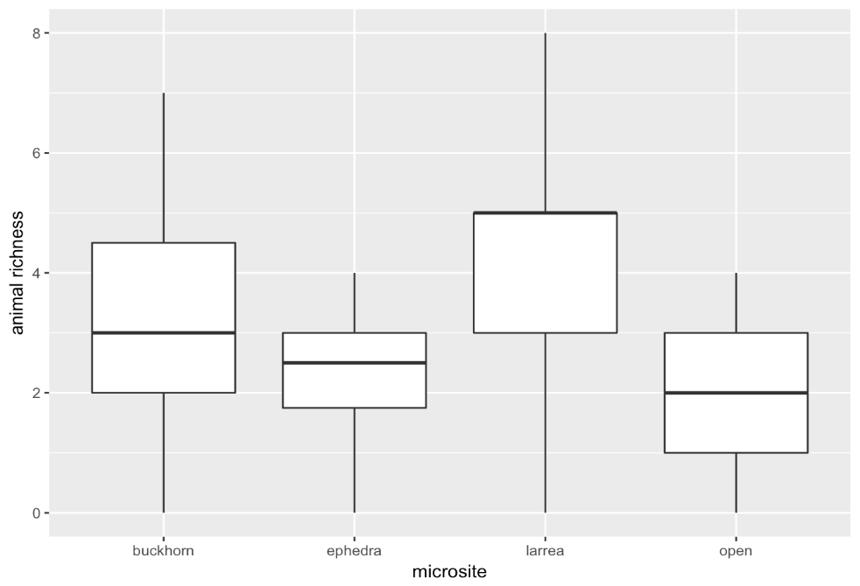

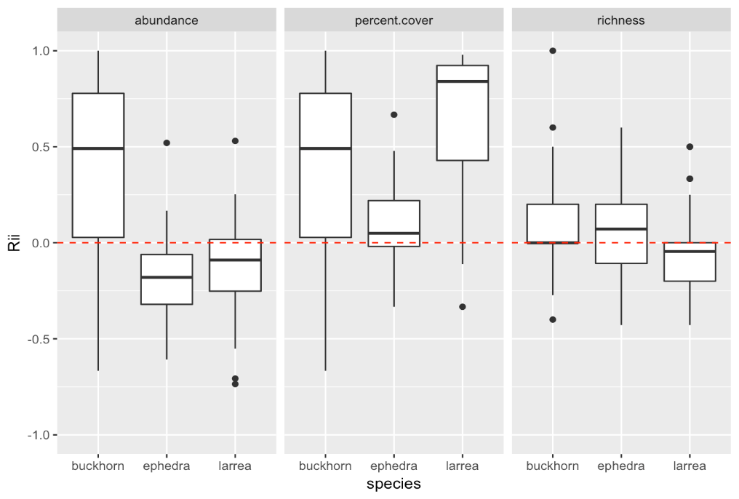**Figure 8.** Species richness at the four microsites is given. Solid lines shows the median of the data, whilst whiskers show 1.5 standard deviation.

**Figure 9.** Relative interaction intensity effect size measure (Rii) for effect of foundational species on the plant community in three categories: abundance, % cover, and richness. Rii has defined limits [-1, +1], is symmetrical around 0, and has absolute values for competition and facilitation.

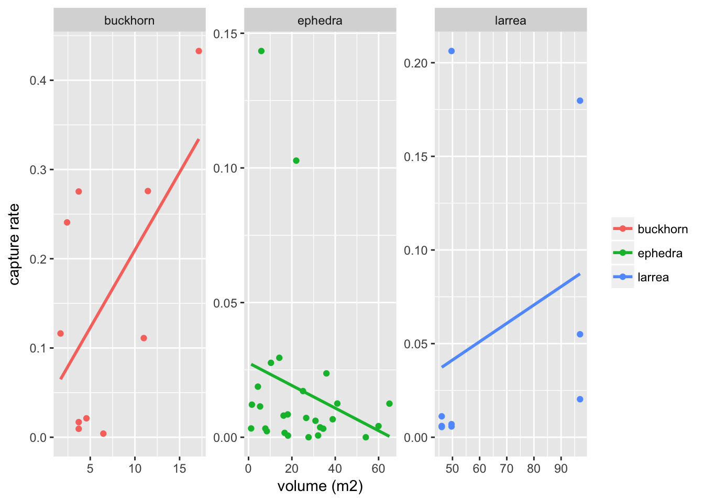**Figure 10.** Linear regression of the shrub volume versus the capture rate for each foundational plant species. Volume was calculated from width and height measurements. Estimates for buckhorn, Ephedra, and Larrea adjusted r2= 0.2628, 0.01436, -0.0388, *p*= 0.07434, 0.2514, 0.43, and *df*= 8, 25, 7, respectively.

**Table 1.** Analysis of deviance between microsites for capture rates.

|  |  |  |  |
| --- | --- | --- | --- |
| Contrast | SE | z-ratio | p-value |
| Buckhorn-Ephedra | 0.549 | 3.399 | 0.0038 |
| Buckhorn-Larrea | 0.445 | 2.644 | 0.0409 |
| Buckhorn-Open | 0.313 | 0.817 | 0.8466 |
| Ephedra-Larrea | 0.629 | -1.098 | 0.6910 |
| Ephedra-Open | 0.544 | -2.957 | 0.0164 |
| Larrea-Open | 0.439 | -2.095 | 0.1548 |

**Acknowledgements**

Special thanks to the Bureau of Land Management, Central Coast Field Office, California for allowing us to do this research funded by NSERC. Thank you to Dr. Lortie for this opportunity and the Ecoblender lab who helped all along the way. Major thanks to Jenna Braun for all her hard work during this study.

**References**

Angelini, Christine, Andrew H. Altieri, Brian R. Silliman, and Mark D. Bertness. 2011. “Interactions among Foundation Species and Their Consequences for Community Organization, Biodiversity, and Conservation.” *BioScience* 61 (10): 782–89. https://doi.org/10.1525/bio.2011.61.10.8.

Asner, Gregory P., and Kathleen B. Heidebrecht. 2005. “Desertification Alters Regional Ecosystem-Climate Interactions.” *Global Change Biology* 11 (1): 182–94. https://doi.org/10.1111/j.1529-8817.2003.00880.x.

Badano, Ernesto I., Omar R. Samour-Nieva, Joel Flores, José L. Flores-Flores, Jorge A. Flores-Cano, and Juan P. Rodas-Ortíz. 2016. “Facilitation by Nurse Plants Contributes to Vegetation Recovery in Human-Disturbed Desert Ecosystems.” *Journal of Plant Ecology* 9 (5): 485–97. https://doi.org/10.1093/jpe/rtw002.

Bråthen, Kari Anne, and Christopher Lortie. 2016. “A Portfolio Effect of Shrub Canopy Height on Species Richness in Both Stressful and Competitive Environments.” Edited by Richard Michalet. *Functional Ecology* 30 (1): 60–69. https://doi.org/10.1111/1365-2435.12458.

Bruno, John F., John J. Stachowicz, and Mark D. Bertness. 2003. “Inclusion of Facilitation into Ecological Theory.” *Trends in Ecology & Evolution* 18 (3): 119–25. https://doi.org/10.1016/S0169-5347(02)00045-9.

Bukombe, John, Andrew Kittle, Ramadhan Senzota, Simon Mduma, John Fryxell, and Anthony R.E. Sinclair. 2018. “Resource Selection, Utilization and Seasons Influence Spatial Distribution of Ungulates in the Western Serengeti National Park.” *African Journal of Ecology* 56 (1): 3–11. https://doi.org/10.1111/aje.12410.

Callaway, Ragan M. 1998. “Are Positive Interactions Species-Specific?” *Oikos* 82 (1): 202. https://doi.org/10.2307/3546931.

Cavieres, Lohengrin A., Ernesto I. Badano, Angela Sierra-Almeida, and Marco A. Molina-Montenegro. 2007. “Microclimatic Modifications of Cushion Plants and Their Consequences for Seedling Survival of Native and Non-Native Herbaceous Species in the High Andes of Central Chile.” *Arctic, Antarctic, and Alpine Research* 39 (2): 229–36. https://doi.org/10.1657/1523-0430(2007)39[229:MMOCPA]2.0.CO;2.

Crist, T. O., D. S. Guertin, J. A. Wiens, and B. T. Milne. 1992. “Animal Movement in Heterogeneous Landscapes: An Experiment with Eleodes Beetles in Shortgrass Prairie.” *Functional Ecology* 6 (5): 536. https://doi.org/10.2307/2390050.

Cromsigt, Joris P. G. M., and Han, Olff. 2006. “Resource Partitioning among Savanna Grazers Mediated by Local Heterogeneity: An Experimental Approach” 87 (6).

Cutler, T.L., and D.E. Swann. 1999. *Using Remote Photography in Wildlife Ecology: A Review*. Vol. 27.

Deborah Stout, Jennifer Buck-Diaz, Sara Taylor, and Julie M. Evens. 2014. “Vegetation Mapping and Accuracy Assessment Report for Carrizo Plain National Monument. California Native Plants Society.” https://www.cnps.org/cnps/vegetation/pdf/carrizomapping_rpt2013.pdf.

Dickson, Brett G., Jeffrey S. Jenness, and Paul Beier. 2005. “Influence of vegetation, topography, and roads on cougar movement in southern California.” Edited by Gehrt. *Journal of Wildlife Management* 69 (1): 264–76. https://doi.org/10.2193/0022-541X(2005)069<0264:IOVTAR>2.0.CO;2.

Drezner, Taly D., and Colleen M. Garrity. 2003. “Saguaro Distribution under Nurse Plants in Arizona’s Sonoran Desert: Directional and Microclimate Influences.” *The Professional Geographer* 55 (4): 505–12. https://doi.org/10.1111/0033-0124.5504008.

Filazzola, Alessandro, and Christopher J. Lortie. 2014. “A Systematic Review and Conceptual Framework for the Mechanistic Pathways of Nurse Plants: A Systematic Review of Nurse-Plant Mechanisms.” *Global Ecology and Biogeography* 23 (12): 1335–45. https://doi.org/10.1111/geb.12202.

Francesco Rovero, Fridolin Zimmermann, Duccio Berzi, and Paul Meek. 2013. “‘Which Camera Trap Type and How Many Do I Need?’ A Review of Camera Features and Study Designs for a Range of Wildlife Research Applications” 24 (2): 148–56.

Gómez-Aparicio, Lorena, Regino Zamora, Jose M. Gómez, Jose A. Hódar, Jorge Castro, and Elena Baraza. 2004. “Applying plant facilitation to forest restoration: a meta-analysis of the use of shrubs as nurse plants.” *Ecological Applications* 14 (4): 1128–38. https://doi.org/10.1890/03-5084.

Grant, Verne, and Paul D. Hurd. 1979. “Pollination of the Southwestern Opuntias.” *Plant Systematics and Evolution* 133 (1–2): 15–28. https://doi.org/10.1007/BF00985876.

Hereford, R., R.H. Webb, and C.I. Longpré. 2006. “Precipitation History and Ecosystem Response to Multidecadal Precipitation Variability in the Mojave Desert Region, 1893–2001.” *Journal of Arid Environments* 67 (January): 13–34. https://doi.org/10.1016/j.jaridenv.2006.09.019.

Hopcraft, J. Grant C., T. Michael Anderson, Saleta Pérez-Vila, Emilian Mayemba, and Han Olff. 2012. “Body Size and the Division of Niche Space: Food and Predation Differentially Shape the Distribution of Serengeti Grazers: Body Size and the Division of Niche Space.” *Journal of Animal Ecology* 81 (1): 201–13. https://doi.org/10.1111/j.1365-2656.2011.01885.x.

Karanth, K. U., J. D. Nichols, N. S. Kumar, W. A. Link, and J. E. Hines. 2004. “Tigers and Their Prey: Predicting Carnivore Densities from Prey Abundance.” *Proceedings of the National Academy of Sciences* 101 (14): 4854–58. https://doi.org/10.1073/pnas.0306210101.

Karanth, K. Ullas. 1995. “Estimating Tiger Panthera Tigris Populations from Camera-Trap Data Using Capture—recapture Models.” *Biological Conservation* 71 (3): 333–38. https://doi.org/10.1016/0006-3207(94)00057-W.

Kelly, Marcella J., Andrew J. Noss, Mario S. Di Bitetti, Leonardo Maffei, Rosario L. Arispe, Agustin Paviolo, Carlos D. De Angelo, and Yamil E. Di Blanco. 2008. “Estimating Puma Densities from Camera Trapping across Three Study Sites: Bolivia, Argentina, and Belize.” *Journal of Mammalogy* 89 (2): 408–18. https://doi.org/10.1644/06-MAMM-A-424R.1.

Lortie, Christopher J., Alessandro Filazzola, and Diego A. Sotomayor. 2016. “Functional Assessment of Animal Interactions with Shrub-Facilitation Complexes: A Formal Synthesis and Conceptual Framework.” Edited by Richard Michalet. *Functional Ecology* 30 (1): 41–51. https://doi.org/10.1111/1365-2435.12530.

Lortie, Christopher J., Eva Gruber, Alex Filazzola, Taylor Noble, and Michael Westphal. 2017. “The Groot Effect: Plant Facilitation and Desert Shrub Regrowth Following Extensive Damage.” *Ecology and Evolution* 8 (1): 706–15. https://doi.org/10.1002/ece3.3671.

Maestre, Fernando T., and Jordi Cortina. 2005. “Remnant Shrubs in Mediterranean Semi-Arid Steppes: Effects of Shrub Size, Abiotic Factors and Species Identity on Understorey Richness and Occurrence.” *Acta Oecologica* 27 (3): 161–69. https://doi.org/10.1016/j.actao.2004.11.003.

McCullagh, Peter. 1984. “Generalized Linear Models.” *European Journal of Operational Research* 16 (3): 285–92. https://doi.org/10.1016/0377-2217(84)90282-0.

Michelle D. Anderson. 2004. “Ephedra Nevadensis. In: Fire Effects Information System.” U.S. Department of Agriculture, Forest Service, Rocky Mountain Research Station, Fire Sciences Laboratory. https://www.fs.fed.us/database/feis/plants/shrub/ephnev/all.html.

Minckley, R. L., J. H. Cane, and L. Kervin. 2000. “Origins and Ecological Consequences of Pollen Specialization among Desert Bees.” *Proceedings of the Royal Society B: Biological Sciences* 267 (1440): 265–71. https://doi.org/10.1098/rspb.2000.0996.

Noble, Taylor J., Christopher J. Lortie, Michael Westphal, and H. Scott Butterfield. 2016. “A Picture Is Worth a Thousand Data Points: An Imagery Dataset of Paired Shrub-Open Microsites within the Carrizo Plain National Monument.” *GigaScience* 5 (1). https://doi.org/10.1186/s13742-016-0145-2.

O’Connell, Allan F., James D. Nichols, and K. Ullas Karanth, eds. 2011. *Camera Traps in Animal Ecology*. Tokyo: Springer Japan. https://doi.org/10.1007/978-4-431-99495-4.

Østbye, Eivind, Mysterud, Atle. 1992. “Cover as a Habitat Element for Temperate Ungulates: Effects on Habitat Selection and Demography” 27 (2): 385–94.

Parmenter, Robert R., and James A. Macmahon. 1988. “Factors Limiting Populations of Arid-Land Darkling Beetles (Coleoptera: Tenebrionidae): Predation by Rodents.” *Environmental Entomology* 17 (2): 280–86. https://doi.org/10.1093/ee/17.2.280.

Parmenter, Robert R., Cheryl A. Parmenter, and Carl D. Cheney. 1989. “Factors Influencing Microhabitat Partitioning among Coexisting Species of Arid-Land Darkling Beetles (Tenebrionidae): Behavioral Responses to Vegetation Architecture.” *The Southwestern Naturalist* 34 (3): 319. https://doi.org/10.2307/3672159.

Pettorelli, N, S Ryan, T Mueller, N Bunnefeld, B Jedrzejewska, M Lima, and K Kausrud. 2011. “The Normalized Difference Vegetation Index (NDVI): Unforeseen Successes in Animal Ecology.” *Climate Research* 46 (1): 15–27. https://doi.org/10.3354/cr00936.

Prieto, Iván, Francisco M. Padilla, Cristina Armas, and Francisco I. Pugnaire. 2011. “The Role of Hydraulic Lift on Seedling Establishment under a Nurse Plant Species in a Semi-Arid Environment.” *Perspectives in Plant Ecology, Evolution and Systematics* 13 (3): 181–87. https://doi.org/10.1016/j.ppees.2011.05.002.

Quinos, Patricio M., Pedro Insausti, and Alberto Soriano. 1998. “Facilitative Effect of Lotustenuis on Paspalumdilatatum in a Lowland Grassland of Argentina.” *Oecologia* 114 (3): 427–31. https://doi.org/10.1007/PL00008819.

R-Core Team 2017 stats. *R package*, R version 3.4.4.

Rovero, Francesco, Emanuel Martin, Melissa Rosa, Jorge A. Ahumada, and Daniel Spitale. 2014. “Estimating Species Richness and Modelling Habitat Preferences of Tropical Forest Mammals from Camera Trap Data.” Edited by Danilo Russo. *PLoS ONE* 9 (7): e103300. https://doi.org/10.1371/journal.pone.0103300.

Sawyer, John O, Todd Keeler-Wolf, and Julie Evens. 2009. *A Manual of California Vegetation*. Sacramento, Calif.: California Native Plant Society Press.

Shryock, Daniel F., Caroline A. Havrilla, Lesley A. DeFalco, Todd C. Esque, Nathan A. Custer, and Troy E. Wood. 2017. “Landscape Genetic Approaches to Guide Native Plant Restoration in the Mojave Desert.” *Ecological Applications* 27 (2): 429–45. https://doi.org/10.1002/eap.1447.

Silver, Scott C., Linde E. T. Ostro, Laura K. Marsh, Leonardo Maffei, Andrew J. Noss, Marcella J. Kelly, Robert B. Wallace, Humberto Gómez, and Guido Ayala. 2004. “The Use of Camera Traps for Estimating Jaguar Panthera Onca Abundance and Density Using Capture/Recapture Analysis.” *Oryx* 38 (02). https://doi.org/10.1017/S0030605304000286.

Sinclair, A. R. E., and P. Arcese. 1995. “Population Consequences of Predation-Sensitive Foraging: The Serengeti Wildebeest.” *Ecology* 76 (3): 882–91. https://doi.org/10.2307/1939353.

White, Gary C. 2005. “Correcting Wildlife Counts Using Detection Probabilities.” *Wildlife Research* 32 (3): 211. https://doi.org/10.1071/WR03123.

**Appendix**

**Table 2.** The latitude and longitude coordinates of the Mojave Larrea and Buckhorn shrub microsites.

|  |  |  |
| --- | --- | --- |
| **Microsite** | **Latitude** | **Longitude** |
| Buckhorn 1 | -115.662° | 34.78264° |
| Buckhorn 2 | -115.663° | 34.78221° |
| Buckhorn 3 | -115.663° | 34.78193° |
| Buckhorn 4 | -115.662° | 34.78169° |
| Buckhorn 5 | -115.662° | 34.78157° |
| Buckhorn 6 | -115.662° | 34.78146° |
| Buckhorn 7 | -115.662° | 34.78121° |
| Buckhorn 8 | -115.662° | 34.78097° |
| Larrea 1 | -115.662° | 34.77835° |
| Larrea 2 | -115.662° | 34.7781° |
| Larrea 3 | -115.661° | 34.77785° |
| Larrea 4 | -115.661° | 34.77751° |
| Larrea 5 | -115.661° | 34.77735° |
| Larrea 6 | -115.661° | 34.77668° |
| Larrea 7 | -115.661° | 34.77638° |
| Larrea 8 | -115.661° | 34.77645° |

**Table 3.** The latitude and longitude coordinates of the Carrizo Ephedra shrub microsites are given for each week during the three week period.

|  |  |  |  |
| --- | --- | --- | --- |
| **Microsite** | **Week** | **Latitude** | **Longitude** |
| Shrub 1 | 1 | 35.11489° | 119.61868° |
| Shrub 2 | 1 | 35.11493° | 119.6188° |
| Shrub 3 | 1 | 35.11472° | 119.61887° |
| Shrub 4 | 1 | 35.11465° | 119.6189° |
| Shrub 5 | 1 | 35.11472° | 119.619° |
| Shrub 6 | 1 | 35.11468° | 119.61913° |
| Shrub 7 | 1 | 35.11472° | 119.61911° |
| Shrub 8 | 1 | 35.1148° | 119.61909° |
| Shrub 9 | 1 | 35.11475° | 119.61929° |
| Shrub 10 | 1 | 35.11494° | 119.61923° |
| Shrub 1 | 2 | 35.11515° | 119.61954° |
| Shrub 2 | 2 | 35.11504° | 119.61957° |
| Shrub 3 | 2 | 35.11493° | 119.61953° |
| Shrub 4 | 2 | 35.11488° | 119.61971° |
| Shrub 5 | 2 | 35.11501° | 119.61988° |
| Shrub 6 | 2 | 35.11507° | 119.61996° |
| Shrub 7 | 2 | 35.11516° | 119.62006° |
| Shrub 8 | 2 | 35.11526° | 119.61982° |
| Shrub 9 | 2 | 35.11532° | 119.6198° |
| Shrub 10 | 2 | 35.11542° | 119.61977° |
| Shrub 1 | 3 | 35.11548° | 119.61973° |
| Shrub 2 | 3 | 35.11543° | 119.6199° |
| Shrub 3 | 3 | 35. 11537° | 119.61993° |
| Shrub 4 | 3 | 35.11543° | 119.61998° |
| Shrub 5 | 3 | 35.11547° | 119.61999° |
| Shrub 6 | 3 | 35.11551° | 119.62013° |
| Shrub 7 | 3 | 35.11554° | 119.62028° |
| Shrub 8 | 3 | 35.11546° | 119.62037° |
| Shrub 9 | 3 | 35.11543° | 119.62035° |
| Shrub 10 | 3 | 35.11539° | 119.62036° |

**Table 4.** Shrub dimension (length, width, and height) are provided for each Buckhorn and Larrea shrub at the Mojave Desert. Dimension are in centimeters.

|  |  |  |  |
| --- | --- | --- | --- |
|  | **Shrub Dimension** | | |
| **Microsite** | **x (length)** | **y (width)** | **z (height)** |
| Buckhorn 1 | 170 | 135 | 146 |
| Buckhorn 2 | 132 | 102 | 122 |
| Buckhorn 3 | 285 | 223 | 128 |
| Buckhorn 4 | 145 | 119 | 113 |
| Buckhorn 5 | 197 | 170 | 145 |
| Buckhorn 6 | 193 | 134 | 115 |
| Buckhorn 7 | 232 | 206 | 145 |
| Buckhorn 8 | 256 | 188 | 153 |
| Larrea 1 | 440 | 414 | 228 |
| Larrea 2 | 363 | 343 | 240 |
| Larrea 3 | 363 | 294 | 165 |
| Larrea 4 | 480 | 425 | 304 |
| Larrea 5 | 406 | 318 | 227 |
| Larrea 6 | 374 | 341 | 263 |
| Larrea 7 | 276 | 292 | 241 |
| Larrea 8 | 403 | 241 | 275 |

**Table 5.** Shrub dimension (length, width, and height) are provided for each Ephedra shrub of the three week census. Dimensions are in centimeters.

|  |  |  |  |  |
| --- | --- | --- | --- | --- |
|  | | **Shrub Dimension** | | |
| **Week** | **Microsite** | **x**  **(length)** | **y**  **(width)** | **z**  **(height)** |
| 1 | Shrub 1 | 278 | 226 | 141 |
| 1 | Shrub 2 | 454 | 338 | 174 |
| 1 | Shrub 3 | 207 | 212 | 116 |
| 1 | Shrub 4 | 273 | 204 | 87 |
| 1 | Shrub 5 | 372 | 307 | 134 |
| 1 | Shrub 6 | 297 | 221 | 87 |
| 1 | Shrub 7 | 193 | 197 | 107 |
| 1 | Shrub 8 | 303 | 293 | 84 |
| 1 | Shrub 9 | 353 | 224 | 131 |
| 1 | Shrub 10 | 402 | 248 | 126 |
| 2 | Shrub 1 | 364 | 303 | 119 |
| 2 | Shrub 2 | 314 | 304 | 104 |
| 2 | Shrub 3 | 212 | 189 | 98 |
| 2 | Shrub 4 | 358 | 283 | 108 |
| 2 | Shrub 5 | 397 | 374 | 127 |
| 2 | Shrub 6 | 362 | 383 | 153 |
| 2 | Shrub 7 | 344 | 282 | 113 |
| 2 | Shrub 8 | 168 | 188 | 102 |
| 2 | Shrub 9 | 261 | 291 | 138 |
| 2 | Shrub 10 | 282 | 216 | 98 |
| 3 | Shrub 1 | 334 | 298 | 156 |
| 3 | Shrub 2 | 215 | 214 | 109 |
| 3 | Shrub 3 | 106 | 122 | 81 |
| 3 | Shrub 4 | 265 | 252 | 84 |
| 3 | Shrub 5 | 141 | 18 | 101 |
| 3 | Shrub 6 | 176 | 168 | 116 |
| 3 | Shrub 7 | 347 | 241 | 112 |
| 3 | Shrub 8 | 108 | 101 | 86 |
| 3 | Shrub 9 | 251 | 252 | 116 |
| 3 | Shrub 10 | 159 | 175 | 184 |